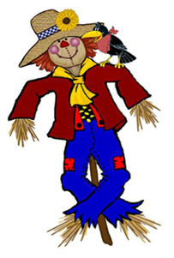
10th Annual Fallbrook Scarecrow Days

TIME TO GET READY
October 2021

Scarecrow Days Rental Agreement

Thank you for participating in Fallbrook ScareCrow Days! The ScareCrew has worked hard to make scarecrows available to you.

Please complete the following for rental(s):

- You/Your business has agreed to rent ______Scarecrow(s) for the month of October 2021 for the amount of $ 35 each.

Total Due $___________

Scarecrow name(s): ___________________________________________

________________________________ ________________________________

- The scarecrow(s) will be returned by you, to the Fallbrook ScareCrew at the end of October.

We look forward to partnering with you again this year and next.

Renters Signature | Contact # and/or email address

ScareCrew Member | Date

Questions: fallbrookscarecrows@gmail.com

